**Experiment 6**

**Draw the DFD to be considered while codding the individual processes or functions.**

**DFD** is the abbreviation for **Data Flow Diagram**. The flow of data of a system or a process is represented by DFD. It also gives insight into the inputs and outputs of each entity and the process itself. DFD does not have control flow and no loops or decision rules are present. Specific operations depending on the type of data can be explained by a flowchart. It is a graphical tool, useful for communicating with users ,managers and other personnel. it is useful for analyzing existing as well as proposed system.

1. **Level 0 DFD:**This is the highest-level DFD, which provides an overview of the entire system. It shows the major processes, data flows, and data stores in the system, without providing any details about the internal workings of these processes.



1. **Level 1 DFD:** This level provides a more detailed view of the system by breaking down the major processes identified in the level 0 DFD into sub-processes. Each sub-process is depicted as a separate process on the level 1 DFD. The data flows and data stores associated with each sub-process are also shown.

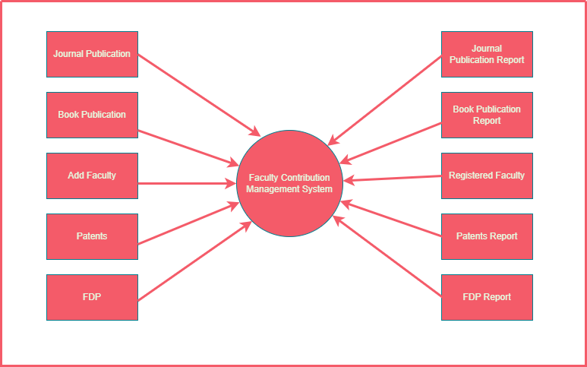

1. **Level 2 DFD:**This level provides an even more detailed view of the system by breaking down the sub-processes identified in the level 1 DFD into further sub-processes. Each sub-process is depicted as a separate process on the level 2 DFD. The data flows and data stores associated with each sub-process are also shown.

